Delete Call
http://corpdevvl204.corp.aires.com:7005/policy-api/benefits/25/duplicate-housing/206

BDD1
Given Duplicate Housing Benefit exists in the Database
When a DELETE call is made
Then the response 200 should be returned
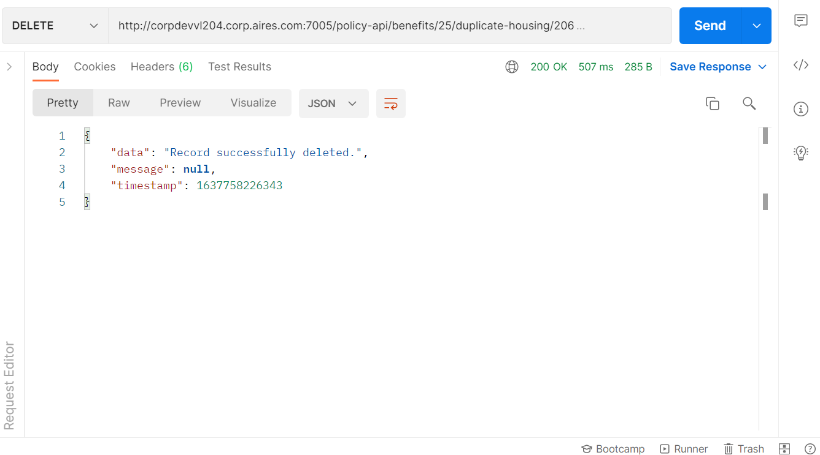

BDD2
Given Duplicate Housing Benefit does not exist in the Database
When a DELETE call is made
Then the response 200 should be returned
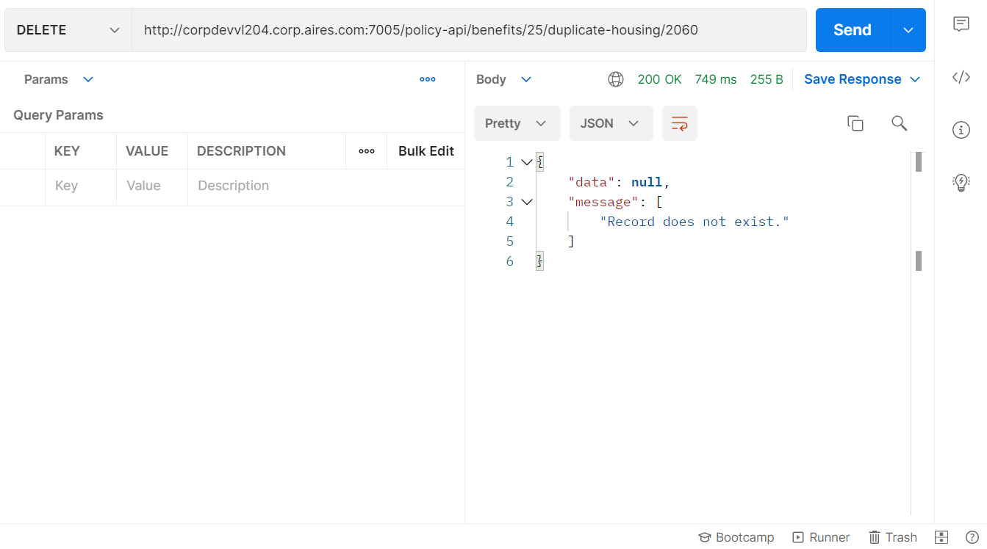

BDD3
Given user enters any string/junk other than the Duplicate Housing Benefit.
When a DELETE call is made
Then the response 400 error should be returned
